**EET 438B**

**Sequential Digital Control and Data Acquisition**

**Laboratory 3**

**Analog Data Acquisition and Aliasing**

**Laboratory Learning Objectives**

1. Use the National Instruments measurement and automation explorer software (MAX) to create a sampled analog task.

2. Inject sine wave signal into a data acquisition application and observe how increasing signal frequency changes with a fixed sampling rate

3. Identify an aliased signal by both time and frequency plots

4. Design an anti-aliasing filter using an OP AMP to eliminate aliasing from a sampled data signal

5. Test the filter design to verify its operation

6. Create a data collection application that processes and displays sampled analog data.

**Theoretical Background**

Collecting data using a computer requires digital sampling of the analog input signals. These samples form a series of numerical values that are available for further processing and analysis. The digital samples represent discrete values of a continuously valued signal. The first step in acquiring digital samples of analog (continuous) signals is to sample it.



Figure 1. Sampled Signal Stem Plot

Figure 1 shows a sampled sine signal represented as a stem plot. The signal only has values at these points. The sample time, Ts, is constant for the entire plot. This is usually the case in most sampled data applications. The inverse of the sample time is the sampling rate, usually given in samples/second.

Equation (1) gives the mathematical representation of this statement. The symbol fs is also

 (1)

known as the sampling frequency with the units of Hertz.

The continuous time signal f(t) has a discrete time representation given as f[n], The function f[n] is an array of numbers that contains the individual samples of the original signal. The function f(nTs), which equals f[n], represents the time function value at the unique sample points determined by the value of n and the sampling time. The variable n is an integer that is the index of the array holding the samples. Figure 2 gives a block diagram of the idealized continuous-to- discrete converter operating at a sampling rate of fs. This block is realized practically in analog-to-digital (A/D) converter circuits. This circuit samples the input and holds the value while converting the analog level to a binary number.

Figure 2. Block Diagram of Ideal Continuous-to-Discrete Converter (C-to-D).

A crucial factor in converting continuous analog signals into digital samples is determining the sampling rate. The Nyquist criterion determines the minimum required sampling rate for accurate reproduction of the original signal. Equation (2) states the Nyquist criterion.

 (2)

Where: fs,min = minimum sampling frequency for total signal recovery

fh = highest frequency in the sampled signal

Equation (3) gives an alternative form of (2). Equation (3) states that the maximum signal

 (3)

frequency that can be accurately reproduced equals one half of the sampling frequency. Equation (2) indicates the minimum required frequency for recovering all the information from the original signal's samples. Higher sampling rates produce sampled signal data that more closely resembles the original signal and can be reconstructed more easily into plots.

Nyquist’s criterion states that sampling a signal at least twice per period results in sufficient information to reconstruct the original signal from the samples. Higher sampling is permitted and makes reconstructing complex signals simpler since the highest frequency component may be unknown, Equation (4) gives the number of samples per period for a given single frequency continuous signal and sampling rate.

 (4)

Where: fin = the highest input frequency of the signal in Hz

fs = the sampling rate in samples/second or Hz

Tin = period of the input signal in seconds

Ts = period of the sampling signal in seconds

np = the number of samples per period of the original signal

Continuous time signals also have a frequency domain representation. This is also known as the frequency spectrum of a signal. This representation shows the range of frequencies contained in the signal on the x-axis and the level of each frequency component on the y-axis. Volts rms, Volts peak and decibels are common methods of displaying frequency component levels in frequency domain representations. Figure 3 shows the frequency spectrum plot of a sine wave given by the following mathematical function. This sine wave has a peak value of 2 volts and a frequency of 100 Hz. Note that all the signal voltage level exists at the 100 Hz frequency of the





Figure 3. Frequency Spectrum of a Single Sine Wave.

continuous time function. A Discrete Fourier Transform (DFT) converts the time domain functional values into the frequency spectrum shown in Figure 3. If the number of sample points Ns=2n, (a power of 2), then a computationally efficient form of the DFT called the Fast Fourier Transform (FFT) rapidly computes the values plotted in the graph. An exact level reproduction at the given frequency requires an integer number of complete cycles of the sampled wave. A sample that does not consist of complete cycles of the sampled wave produces a phenomena called spectral leakage that spreads sampled signal's level over a wider part of the frequency spectrum. Figures 4a and 4b show the time and frequency plots of the function above sampled over a non-integer number of cycles. The voltage level spreads over a range of frequencies



Figure 4a. Frequency Spectrum of Non-Integer Cycle Sample. Note The Reduction of Amplitude Due to Spectral Leakage.



Figure 4b. Time plot of Non-Integer Cycle Sample. The Plot Covers Two Complete Cycles. The Fractional Cycle Causes the Spectral Leakage

about the frequency of the function. This is due to the computations of the DFT/FFT and is not in the actual signal. Triggering on a specific waveform location like the positive-going zero crossing and proper selection of the sampling time can produce an integer number of cycles and reduce the spectral leakage in a sampled signal.

Some DFT/FFT calculations produce frequency plots that include both positive and negative values of frequencies. Negative frequencies represent phasors that rotate in the opposite direction to the positive frequencies. They are part of the calculations of the DFT/FFT and are not part of the actual signal. For plots that include negative frequencies, the zero frequency, dc value is in the middle of the spectrum. When the DFT/FFT represents the signal with both positive and negative frequencies, the magnitude of the signal divides between those two components. Since the DFT/FFT is symmetric about 0 frequency, the total signal magnitude is twice the value of it component.

More complex time functions produce a range of components in the frequency domain with different levels. The function below represents amplitude modulation (AM) of two sine waves.



The frequency plot in Figure 5 shows that this type of modulation produces sums and differences of the two signal values. The sampling process in the C-D conversion process is AM modulation that produces similar frequency plots. The function above represents a 100 Hz sine wave sampled at 1000 Hz (samples/second) This is well above the Nyquist frequency and the signal is recoverable.



Figure 5. Frequency Domain Plot of AM Modulation of 100 Hz Information by 1000 Hz Carrier.

The sampling rate, fs, and the total number of samples, Ns, determine the frequencies found from the DFT/FFT calculations. The DFT/FFT can only find frequencies below fs/2. The number of points determines the frequency resolution of the sampled signal. Equation 5 gives the frequency scaling increment value.

 (5)

Where: fs = the sampling rate (samples/second, Hz)

Ns = the total number of samples taken

f = the frequency scaling increment

Sampling a signal below the Nyquist frequency causes the reproduction of signals with frequencies not present in the original information. Sampling below the Nyquist frequency given in Equations (2) and (3) is called under sampling. Under sampling produces aliasing and folding. These effects cause incorrect reconstruction of the sampled signals.

Aliasing occurs when the sampling rate is below the highest frequency in the input, fh. For the first sine function above this is any frequency below 100 Hz. The aliased signal reconstructed will be the difference between the input frequency and the sampling rate. If fs is 80 Hz for the 100 Hz sine wave the resulting aliased signal will be 20 Hz. Sampling a signal at exactly its frequency would capture the same point for each sample taken. This would result in a dc value being reconstructed. If the sampling captures a zero crossing at each sampling instant, the dc value would be zero.

Figure 6 shows the time and frequency plots of the example described above with an 100 Hz signal sampled at 80 Hz

 

Figure 6. Aliased Signal Resulting From Under Sampling 100 Hz with fs= 80 Hz.

Folding occurs for sampling frequencies between fh< fs< 2fh, where fh is the highest frequency component in the input signal and 2fh is the Nyquist minimum sampling rate. Equations 6 below gives two possible aliased frequencies due to folding.

 (6)

Where: f = the input signal frequency component (Hz)

fs = sampling rate (samples/second)

fa1 = aliased frequency 1 (Hz)

fa2 = aliased frequency 2 (Hz)

For an input signal of 100 Hz with a sampling rate of 180 Hz the above equations produce the following aliases:



So sampling a 100 Hz sine signal at 180 Hz produces the same samples as an 80 Hz sine wave. Figure 7 shows the time samples and frequency plots for the example above. The frequency plot

 

Figure 7. Stem Plot and Frequency Spectrum Showing Aliased Signals Due To Sampling Below the Nyquist Rate.

only shows the positive alias in this case. Some DFT/FFT calculations will produce a two-sided frequency domain plots showing the negative and positive frequencies.

It is difficult to determine the exact frequency content of complex waveforms such as music and speech, but it is possible to determine an upper frequency limit. When the upper limit is not known, an anti-aliasing filter can prevent signal aliasing by restricting the bandwidth of the incoming signal to frequencies below the minimum sampling rate defined by Nyquist. Active low-pass filters are effective as anti-aliasing filters. The low-pass filters limit the magnitude of frequencies above the sampling rate and prevent aliasing. Nyquist's criterion guarantees accurate reproduction of all signals below this rate.

Setting the filter cut-off frequency to the Nyquist frequency reduces the magnitude of the frequencies above this value The amount of signal reduction depends on the type of filter used. Figure 8 shows an active 1st order low pass filter This filter attenuates frequencies above the cut-off frequency based on Equation (7).

 (7)

Where: Av = the voltage gain of the filter in the stop band (dB)

Vo = the filter output voltage at a given frequency

Vi = the filter input voltage at a given frequency.



Figure 8. First Order Active Low Pass Filter Implemented With an LM741 OP AMP.

Equations (8) and (9) give the values of cut-off frequency, fc, and dc gain Avdc for the values of R1, R2 and C1. The dc gain is the amplification factor of all frequencies much lower than fc.

 (8)

 Hz (9)

Making the value of R1=R2 creates an inverting unity gain filter with an attenuation factor of- 20 db/decade of frequency change.

Higher order filters give increased signal attenuation above the cut-off frequency producing a more ideal bandwidth-limited signal. Figure 9 shows a 2nd order, unity gain low pass filter constructed using a LM741 OP AMP.



Figure 9. Second Order Low Pass Filter

This filter produces a frequency response in the stop band given by Equation (10). This filter produces a -40 dB/decade attenuation of signals above the value of fc. Equations 11a-11c are the design equations for this circuit.

 (10)

 (11a)

 (11b)

 (11c)

Both filters reduce the input signal level by a factor of 0.707 of the maximum input level at the cut-off frequency. The 1st order filter reduces the input level by a factor of 1/10 for every -20 dB of gain for signal frequencies above fc. This corresponds to a level reduction of 1/10 for every decade of frequency increase. The second order filter produces an input level reduction of 1/100 for every -40 dB of gain corresponding to an attenuation of 1/100 per decade of frequency increase beyond fc.

The value of a filters cut-off frequency can be set based on a desired signal level at the Nyquist sampling rate. Equation (12) gives the relationship between the cut-off frequency, fc, the sampling frequency, fs, and the desired signal gain at fs, Av for a 1st-order filter with unity gain.

 (12)

Where 

Vo = Desired output voltage level at the sampling frequency.

Vi = The input voltage level of the sampled signal.

fs = the signal sampling rate.

fc = the filter cut-off frequency to achieve the desired level at the sampling frequency.

Setting a 1st order filter's cut-off frequency to the value computed using (12) will attenuated all signals to the ratio specified by Av and eliminate aliasing for frequencies above this point. Also note that setting Av<1 will reduce the usable sampling bandwidth to values less than the Nyquist frequency of fs/2.

Equation (13) gives the cut-off frequency for a 2nd order filter with unity gain for a desired attenuation level and sampling frequency. This filter has a stop band response of twice a 1st order filter. This more closely approximates the response of an ideal filter. The effective

 (13)

Sampling range of a system using this type of filter will be larger than that of a system using a 1st order anti-aliasing filter due to the greater response slope in the stop band. The equations below define values of Av and fc for the 2nd order filter,



with the same component constraints given in (11a) and (11b).

The series connection of 2nd order filter stages gives even sharper reduction of signals beyond the cut-off frequency with little signal reduction below this frequency. Cascading 2, 2nd order filters creates a 4th order response with a gain slope in the stop band of 80 dB/ decade. This type of filtering can create an almost ideal filter response and allow signals to pass un-attenuated up to the Nyquist sampling rate but produce a band width limited signal with little chance of aliasing.

**Procedure**

1. View the instructional video on using the National Instruments Measurement and Automation Explorer software (NI-MAX).
2. Open the NI-MAX and create a data acquisition task to measure an input voltage on analog channel ai0. Set the task name to “aliasingtest”, without the quote marks. Define the following parameter in the task setup.

Terminal Configuration: Differential

Acquisition Mode: N-samples

Clock Setting

Samples to Read: 2048

Rate (Hz): 4 kHz

Save the task before exiting the NI-MAX.

1. Start LabVIEW and find the Virtual Instrument (VI) called ***signaltest.vi*** and load it into LabVIEW.
2. Connect color coded wires to the differential terminals for analog input ai0. Use the connection diagram tab on the defined task setup to locate the correct terminals for the data acquisition card and terminal block used on the particular computer used for this experiment. Figures 10a and b show the location of the tab and typical connections ai0.
3. Set the function generator output to sine waves with no dc offset and an output level of 1 V peak using an oscilloscope. Set the frequency to the first entry in Table 1. Connect the function generator to the leads connected to the terminal block locations from step 4.

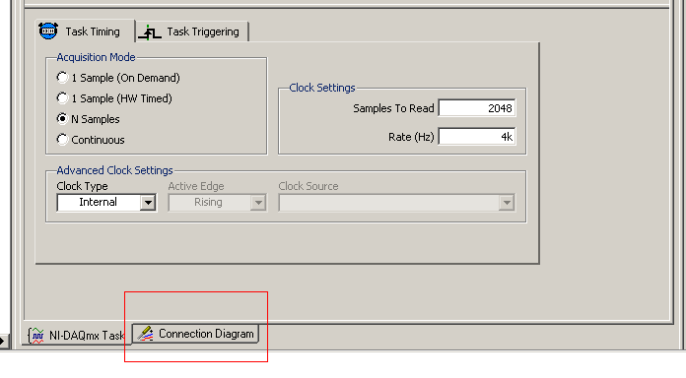

Figure 10a. Location of the Connection Diagram Tab in the NI-MAX.

1. Start the ***signaltest.vi*** .
2. Use the Capture Data Button on the VI to sample the connected sine wave signals produced by the function generator. Adjust the time and frequency scaling

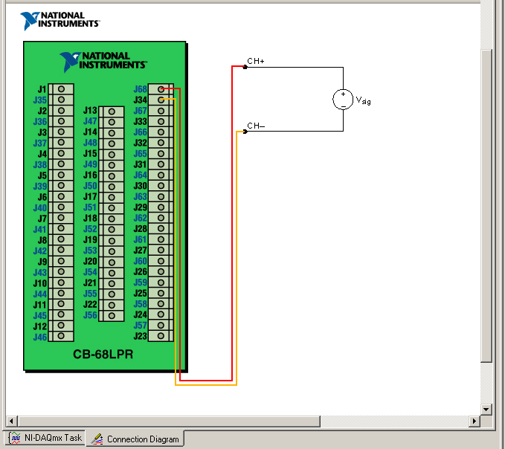

Figure 10b. Typical Connection Diagram Results From the Connection Diagram Tab.

knobs as necessary to show the time and frequency spectrums of the input value. Use the measurement cursors on the graphs to locate and measure the frequency components and magnitude.

1. Compute the number of sample points acquired per period for the input frequency using Equation (4) from the Theoretical Background section.
2. Repeat steps 7 and 8 for all frequencies listed in Table 1. Note when aliasing and folding occurs. Stop the VI and disconnect the function generator after completing all measurements in the table.
3. Using the 1st-order filter schematic shown in Figure 8 and Equations (8) and (9), design an anti-aliasing filter with a cut-off frequency that will reduce all frequency components greater than the Table 1 frequency where aliasing begins, approximately fs/2. The gain in the passband should -1. Let the gain at the Nyquist frequency be Av=0.5 and use equation (12) to find the value of fc that will give Av=0.5 at the Nyquist frequency. Use capacitor values in the range of 0.1-0.0001 f for the capacitor C1 in the circuit. Use an LM741 OP AMP for the ideal device shown.
4. Simulate the design in MultiSim, Circuitmaker, or LTSpice. Use the AC analysis simulation to check the cut-off frequency of the design. Print both the schematic and the frequency plot to document the circuit operation.
5. Construct the designed circuit on a solderless board and power it with ±12 Vdc supplies. Connect the 1st-order filter between the function generator and the leads to the data acquisition terminal board as shown in Figure 11.



Figure 11. Anti-Aliasing Filter Connections Into System.

1. Repeat steps 7-9 for all values in Table 2.
2. Use the schematic diagram in Figure 9 and Equations (11a)-(11c) to design an anti-aliasing filter with the same Av value at the Nyquist frequency used in Step 10. Use capacitor values in the range of 0.1-0.0001 f for capacitors C2 and C3 in the circuit. Use an LM741 OP AMP for the ideal device shown.
3. Simulate the design in MultiSim, Circuitmaker, or LTSpice. Use the AC analysis simulation to check the cut-off frequency of the design. Print both the schematic and the frequency plot to document the circuit operation.
4. Construct the designed circuit on a solderless board and power it with ±12 Vdc supplies. Connect the 2nd-order filter between the function generator and the leads to the data acquisition terminal board as was done for the 1st-order filter in the previous step.
5. Repeat steps 7-9 for all values in Table 3.
6. Write a short report (1-2 double-spaced pages) that compares the data in Tables 1-3. Address the following questions in the report.

What is the Nyquist criterion? At what frequency does aliasing and folding occur? What affect does the addition of the anti-aliasing filters have on the magnitudes of the frequencies that are above and below the cut-off frequency? How does the number of samples/period affect the reconstructed time graph?

**Programming Assignment**

View the Reading Analog Input and X-Y graphing demonstration videos to prepare for this part of the assignment.

1. Use the NI-MAX to create a virtual task to read analog data from channel ai3. (Note: online students should use channel ai1 of the myDAQ data acquisition system.) The task should use a differential input, take 4096 data points, and sample at a rate of 5000 samples/second (Hz). Name the task **myanalogin**. Set the acquisition mode to N-samples and save the task before leaving the NI-MAX.
2. Create a VI that graphs samples from the task defined above. Figure 12 below shows the desired user interface. The program should have a functional stop button, an Acquire Wave button, and a Clear Graph button. Pressing the Acquire Wave data should plot the

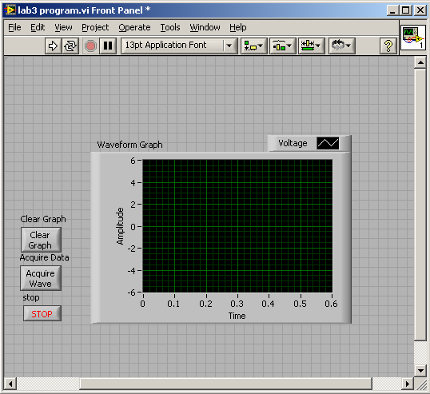

sampled data. The program should maintain the plot until the user presses the clear graph button. The STOP button will end the program.

3.) Test the program by injecting a 1 V peak sine wave into the analog input defined in the task. Vary the frequency of the sine wave and note how the graph changes with frequency. Inject a square wave with zero dc offset, a 50% duty cycle, and a 1 V peak amplitude. Vary the frequency and observe the effects of sampling on the high frequency components of the square wave. What is the maximum frequency that the task can accurately reproduce the square wave.

4,) Print the front and back panels of the VI and include them in the report.

**Lab 3 Assessment**

Complete and submit the following items for grading and perform the listed actions to complete this laboratory assignment.

1. Complete the online quiz over Lab 3 theory.
2. Submit the simulations from the 1st order anti-aliasing filter hardware design.
3. Submit the simulations from the 2nd order anit-aliasing filter hardware design
4. Completed Tables 1,2 and 3 with all data taken and computations completed
5. Written comparison of the values taken in tables as described in step 18 in the procedure.
6. Submit front and back panel printouts of LabVIEW programming assignment given in the lab document.

Table 1 Aliasing Measurements for Direct Sine Wave Input

|  |  |  |  |
| --- | --- | --- | --- |
| Sine Input Frequency (Hz) | Measured (Hz) | Number of Sample Points/Input Period | Spectrum Amplitude  (V peak) |
| 50 |  |  |  |
| 100 |  |  |  |
| 200 |  |  |  |
| 400 |  |  |  |
| 800 |  |  |  |
| 1000 |  |  |  |
| 1200 |  |  |  |
| 1500 |  |  |  |
| 1800 |  |  |  |
| 2000 |  |  |  |
| 2500 |  |  |  |
| 3000 |  |  |  |
| 3500 |  |  |  |
| 4000 |  |  |  |
| 4200 |  |  |  |

Table 2 Aliasing Measurements for Sine Wave Input Through A 1st-Order Anti-Aliasing Filter

|  |  |  |  |
| --- | --- | --- | --- |
| Sine Input Frequency (Hz) | Measured (Hz) | Number of Sample Points/Input Period | Spectrum Amplitude  (V peak) |
| 50 |  |  |  |
| 100 |  |  |  |
| 200 |  |  |  |
| 400 |  |  |  |
| 800 |  |  |  |
| 1000 |  |  |  |
| 1200 |  |  |  |
| 1500 |  |  |  |
| 1800 |  |  |  |
| 2000 |  |  |  |
| 2500 |  |  |  |
| 3000 |  |  |  |
| 3500 |  |  |  |
| 4000 |  |  |  |
| 4200 |  |  |  |

Table 3 Aliasing Measurements for Sine Wave Input Through A 2nd-Order Anti-Aliasing Filter

|  |  |  |  |
| --- | --- | --- | --- |
| Sine Input Frequency (Hz) | Measured (Hz) | Number of Sample Points/Input Period | Spectrum Amplitude  (V peak) |
| 50 |  |  |  |
| 100 |  |  |  |
| 200 |  |  |  |
| 400 |  |  |  |
| 800 |  |  |  |
| 1000 |  |  |  |
| 1200 |  |  |  |
| 1500 |  |  |  |
| 1800 |  |  |  |
| 2000 |  |  |  |
| 2500 |  |  |  |
| 3000 |  |  |  |
| 3500 |  |  |  |
| 4000 |  |  |  |
| 4200 |  |  |  |