**EET 438B**

**Sequential Digital Control and Data Acquisition**

**Laboratory 5**

**Dc Bridges in Measurement and Data Acquisition**

**Laboratory Learning Objectives**

1.)Explain how a dc bridge measures unknown resistance values.

2.) Explain the difference between balanced and unbalanced dc bridge operation.

2.) Explain how a dc bridge coverts a sensor resistance change into an output voltage when the bridge operates in the unbalanced mode

2.) Determine the relationship between a unknown resistance and the dc bridge output voltage.

3.) Identify the balance conditions for a dc bridge circuit.

4.) Define an analog output channel in NI-MAX and utilize it in a LabVIEW program.

4.) Construct a dc bridge circuit and automate the measurement process of unknown resistor values using a data acquisition board and a LabVIEW program.

5.) Convert the bridge measurement into a correctly scaled resistance value and display it on the front panel of a LabVIEW program.

**Theoretical Background**

A dc resistance bridge, also known as a Wheatstone bridge, is a simple but accurate circuit for measuring unknown resistance values. The Wheatstone bridge is able to make accurate resistance measurements on resistance values as low as mili-ohms. This basic circuit also finds application in measuring mechanical properties such as force, pressure, light and temperature when the bridge includes a sensing device who's resistance varies with the physical property. The circuit makes highly accurate measurements since it acts to reduce an output voltage to zero (nulling measurement) instead of determining an absolute value and displaying it directly.

Figure 1 shows two schematic representations of the Wheatstone bridge. Figure 1B is the common representation of the bridge circuit. Figure 1A highlights the fact that the bridge circuit

Figure 1. Schematic Representations of the Dc Bridge (Wheatstone Bridge)

consists of two parallel voltage dividers connected by a current measuring device. In some dc bridge schematics, a fixed resistor or a voltmeter connect the points labeled Va and Vb and form the output of the bridge circuit.

A dc bridge can operate in two modes: balanced and unbalanced. Resistance measurement circuits utilize the balanced operating mode. Sensor interface circuits typically use the unbalanced operating mode to convert small resistance changes in a sensor into an output voltage measured between points Va and Vb. The dc bridge operating in the balanced mode uses a variable resistance, R3, to adjust the right-hand voltage divider circuit until Vb equals Va. The values of the unknown resistance Rx and R1 form the left-hand voltage divider circuit and set the value of Va. The ammeter indicates the balance point when it reads zero current. Ammeters used for this indicator must read both positive and negative current since Vb>Va or Vb<Va initially. The ammeter can be replaced by a voltmeter connect between points Va and Vb. It will read zero at the balance point as it senses the voltage difference between the two voltage divider circuits. At the balance point Va=Vb, so Va-Vb=0 . Replacing the voltmeter by a fixed resistor provides an indirect method of measuring the current between Va and Vb. Connecting differential input analog voltage channels from a data acquisition board across the fixed resistor allow a PC to measure the voltage/current while changing R3 to achieve balance.

Equation (1) relates the known values of R1, R2 and the adjusted value of R3 to the unknown resistance Rx. Note that the value of Vdc does not enter into the computation so variation in the supply voltage do not affect the measurement accuracy.

 (1)

The value of R3 is fixed when operating a dc bridge in the unbalanced mode. The resistor Rx represents a sensor who's resistance varies with changes in force, light or temperature. These resistance changes are usually quite small. A dc bridge designed for unbalanced operation has values of R1-R3 adjusted to give the bridge sensitivity and linearity. Equation (2) shows the relationship between the bridge voltage output and the sensor resistance change. This equation

 (2)

assumes that R2=R3 and that R1=Rx for some sensor input stimulation. The second equality is the balance condition for dc bridge operation. The final values of R1-R3 are a compromise between voltage sensitivity and linearity. The bridge voltage output is only approximately linear over a small range of sensor resistance change. Increasing the bridge sensitivity produces more output voltage but increases the non-linear response of the output voltage.

An automated resistance measurement using a balanced dc bridge is possible utilizing computer-based DAQ board input/output channels. Computer control of the dc bridge requires a modification of basic dc bridge circuit of Figure 1. Digitally controlled potentiometers exist but Figure 2 shows an alternative circuit that uses an analog voltage output channel of the National Instrument DAQ boards. This circuit includes a dc voltage source, Vao, that represents an analog voltage output from the DAQ board. The resistor Rs is an external current limiting resistor that



Figure 2. Wheatstone Bridge Circuit Modified For Computer Control.

also provides a means of measuring the current in this circuit branch. The values of R1 and R2 are fixed and determine the bridge measurement range. The resistor Rx represents the unknown resistor value tested.

The analog output channels of the NI DAQ boards have a maximum output range of ±10 V and can source up to 5 mA of current. Writing voltage values to the analog output while measuring the differential voltage across resistor R3 automates the measurement of unknown resistors using the Wheatstone bridge. The relationship in (1) needs to be redefined in terms of Vao and Rs.

Adjusting the value of the analog output source, Vao, changes the value of Vb. The value of Vb of a balanced bridge in terms of the branch components is

, (3)

where Is is the current flowing through the resistors R2 and Rs at balance. Writing a KVL equation around the loop that contains Vdc, R2, Vao and Rs and solving for the current Is gives

 (4)

Combining (3) and (4) expresses Vb in terms of the right-hand voltage divider resistors and the analog output voltage. At the balance point, Va=Vb, so using the voltage divider formula on the left-hand voltage divider and equating the expressions for Va and Vb gives (5).

 (5)

Letting R1=R2 and solving Equation (5) for Vao produces an expression that relates the unknown resistance to the balancing voltage from the DAQ board. Equation (6) gives this result.

 (6)

Since Vao is the independent variable and adjusted to achieve the balance condition, solving (6) for Rx produces a more useful equation that will relate the analog output voltage from the DAQ board to the unknown resistance. Equation (7) gives this result.

 (7)

Examining (7) identifies the limitations of this scheme and how changing the parameters Vao and Rs affect the measurement range. If the analog output voltage is zero, (7) reduces to



with the value of Rx determined by R2 and Rs. If the value of Vao=Vdc the value of Rx goes to zero regardless of it actual value. This places lower and upper bounds on the analog output. This formula shows that 0<Vao <Vdc for proper measurements.

Controlling the value of Vao using a DAQ board allows the PC to automate resistance measurement using the dc bridge if detecting the balance point is possible. When the voltage difference between Va and Vb is zero the bridge is balanced and the value of Vao for this condition relates to Rx through Equation (7). An analog input channel set to read differential voltage and with proper scaling can read the voltage drop across R3, which is Vab=Va-Vb, as the analog output voltage changes. This measurement completes a control loop. Adjusting Vao in a systematic way that produces lower values of Vab would drive the bridge to a balance point. The voltage, Vao that produces Vab=0 would determine the value of Rx when placed in Equation (7).

**Binary Search Algorithm for Balancing a Dc Bridge**

Equation (8) relates the analog output Vao to the value of Vab in terms of all the bridge resistances and the dc supply value. The first term in (8) becomes a constant after selecting an Rx value. The coefficient of Vao is also a constant with the values of R2 and Rs determined

 (8)

The following definitions simplify (8) and illustrate the linear nature of this relationship. Equations (9a) and (9b) define the intercept and the slope of a line that

 (9a)

 (9b)

 (9c)

decreases with increasing values of Vao. If a value of Vao produces a Vab=0 in the interval Vaomax to Vaomin then balancing the bridge is possible. Figure 3 graphs Equation (9c) for given resistances and supply voltages. The balance point occurs when the Vab line intersects the x-axis. A binary search algorithm uses a systematic approach to finding this point based on analog voltage outputs and inputs measured using the DAQ board.

The binary search algorithm assumes that there is a function, f(x) with a zero value within an interval defined by [a, b]. A sign change of a functional evaluation indicates that a zero occurs somewhere in the given interval. The starting interval is divided in two and a new end point established. The search algorithm then evaluates the function at the interval endpoints, f(pnew) and f(b) and tests for a sign change in interval with f(pnew)∙f(b)>0. If a sign change occurs, f(pnew)∙f(b)<0, and the appropriate endpoint is updated. The process repeats until the maximum number of iterations is exceeded or a zero is found. The equation below determines the new endpoint for iteration I in term of the dc bridge application.

 (10)

Where pnew,i = updated endpoint for iteration i

Vaomin(i-1) = Minimum analog output from last iteration, i-1

Vaomin(i-1) = Maximum analog output for the last iteration, i-1

Figure 3 shows the computed values of pnew and how the interval limits change in the search of the zero point of the graphed function. Figure 4 gives the pseudo-code for a binary search algorithm to find the balance point of the dc bridge.



Figure 3. Measured Vab As A Function of Analog Output Showing the Steps of Binary Search for Vbal.

The algorithm starts by initializing the variable used to hold the final value of Vao that balances the bridge to zero. The next step is to write the maximum and minimum analog output values to the circuit and read the resulting values of Vab. An IF-THEM Statement tests the resulting values of Vab to determine if a sign change occurs in the interval defined by the analog outputs. If the product of the two values is positive then a sign change does not occur in the interval and the bridge cannot be balanced. If this condition is true the program outputs -100 to indicate no solution and then ends.

If a sign change occurs within the limits of Vao, the program enters a WHILE loop with the maximum number of iterations set by Nmax. This prevents the program from entering an infinite loop. Once in the while loop, the program computes the updated value for analog output in iteration i, Vaoi. The program writes this value to the analog output channel and reads the resulting value of Vab. If the absolute value of Vab is sufficiently close to zero as determined by the tol value, then the program sets the current value of Vaoi equal to Vbal and exits the program. If the returned value of Vab in outside the specified tolerance, then the program increments the loop counter and proceeds to test and update the search limits. The program takes product of the current value of Vabi and the Vab resulting from outputting the lower limit and tests to see it the result is positive. If this condition is true, the program updates the lower limit. If the test is false, then the code updates the upper limit. Successive iterations of the WHILE loop should reduce the search interval until the program converges on the value of Vao that produces a balanced dc bridge.

BEGIN

Vbal =0 //initialize Vao at balance to zero

Output Vaomax //write max value to analog output

Read Analog Input Vabmax //read value of Vab on analog input

Output Vaomin //write min value to analog output

Read Analog Input Vabmin

//Test to see if a zero exists on the interval

IF Vabmax)∙ Vabmin>0 Then

Vbal=-100 // test indicates no zero crossing in interval output. -100 failure value

STOP PROGRAM // end program if no solution exists

END IF

Nmax = k //initialize max number of iterations to a constant k

i=0 // set loop counter to zero.

WHILE i≤Nmax

Vaoi = Vaomin+(Vaomax-Vaomin)/2 //shorten interval

Output Vaoi

Read Vabi

IF |Vabi|<tol THEN //test to see if current value is near zero tol= small number

Vbal=Vaoi //value is close enough to zero output and end while

Break from while

END IF

i=i+1 // increment loop counter

// Test end points and update as necessary

IF Vabi∙ Vabmin>0 THEN

Vaomin=Vaoi //increase minimum value

ELSE

Vaomax=Vaoi  // decrease max value

END IF

END WHILE //end the while loop here

END //program

Figure 4. Pseudo Code for Binary Search Algorithm Used To Find Analog Output Balance Voltage.

**Programming Project Description**

The purpose of this laboratory project is to design an automated dc bridge (Wheatstone Bridge) to determine the value of an unknown resistance. A LabVIEW program will adjust an analog voltage source output while monitoring an analog voltage input channel. The analog voltage input will be set to read the differential voltage, Vab defined in the theory section. A binary search subroutine will take differential input voltage measurement values and adjust the analog output until balanced is achieved. A program display will update the values of Vao and Vab as the search process proceeds to completion. The program display will also show the final value of the unknown resistance that was computed from Equation (7) after finding the Vao value that balances the bridge circuit. Start and Stop buttons begin and end the measurement process. An indicator LED lights when the bridge is balancing. Figure 5 shows the desired front panel display for the program.

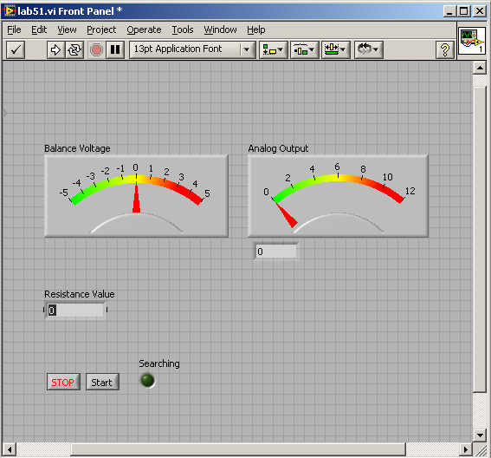

Figure 5. Front Panel Display For the Automated Resistance Bridge.

**Procedure**

1. Design a bridge circuit using the schematic in Figure 2. The following design parameters are already defined as:

Vdc = 12 Vdc

Vaomax = 10 Vdc

Vaomin = 0.25 Vdc

R3 = 1000 

Rs = 470 

Measurement Range: Rxmin≥2,000  and Rxmax ≥ 130,000 

Use Equation (7) to find a value of R1=R2 for the range of Rx that includes a minimum and maximum values defined above. Pick a value of R2 and use the defined range of Vao in (7) to check if the resister value produces the specified range. If the computation of R2 produces a non-standard value, use the nearest standard resistor value. Plot Equation (7) in Excel using the values of R1 and R2 found above over the range of Vao specified. Determine if the relationship between Vao and Rx is linear based on the plot. If the plot is non-linear convert the y-axis to a logarithmic scale and observe the results. Save the calculations used to find R1 and R2 and the Excel spreadsheet with the plots for later use. Record the resistor values used to construct the bridge in the spaces provided in the Appendix.

1. Use the values of R1,R2, R3, Rs and an initial Rx=2200 ohms to plot Equation (8). Find the value of Vab at 0.25 V increments for the range of Vao specified above. From this plot determine the minimum and maximum values of Vab. Compute the span of Vab for this value of unknown resistance. Enter these values into Table A-1 in the Appendix. Repeat the above calculations for the remaining two values in Table A-1. From these results determine the best analog input voltage range to measure Vab with the best resolution. Use the data sheets of the DAQ boards to determine the analog input ranges.
2. Using the range selected in step 2, compute the voltage value of the LSB. Find the number of bit used in the analog input from the DAQ board specifications and record them in the Appendix. Compute the value of VLSB and record it in the Appendix. Note this value and use it to determine the stopping tolerance in the binary search. Set the tolerance from 10 to 100 times this value to ensure that the program will stop.
3. View the videos that demonstrate how to create analog input and output channels using the NI-MAX software.
4. Use the NI-MAX software to create DAQmax global virtual channels for an analog output using the ao-0 analog output channel and an analog input using ai6. Make the analog input read differential inputs not RSE, which is the default.
5. Construct the bridge circuit shown in Figure 6 using the computed values of R1 and R2 and an initial value for Rx of 2200 ohms. Connect the DAQ board analog output channel and scalar/analog input as shown in the schematic.



Figure 6. Automated Resistance Measurement Bridge Circuit Showing Required External Connections to the DAQ Board. The Scalar Circuit Maybe Necessary to Obtain Adequate Resolution.

1. View the videos that explain the LabVIEW programming techniques used to make subVIs and that demonstrate programming methods in LabVIEW.
2. Develop a LabVIEW Program using the binary search routine as a subVI that gives the desired functionality stated in the project description. Use the pseudo code in the Appendix as a start for the program.
3. Test the program and the external circuit using Rx=2200 ohms. Troubleshoot the combined hardware and software system as necessary. Use the test panel in the NI-MAX to verify the input and output of the DAQ board if necessary. Use data probes and breakpoints to debug the programs.
4. Complete Table A-2 in the Appendix for the listed values of Rx. Use the automated resistance bridge to measure the ten resistance values listed. Use the lab DVM to measure the same resistor. Use the formula below the table to compute the percentage difference in the readings. Save the results to document your work.

**Lab 5 Assessments**

Submit the following items for grading and perform the listed actions to complete this laboratory assignment.

1. Submit the calculations used to determine the values of R1 and R2. These design calculations should be neatly organized on engineering paper.
2. Excel plots of Equation (7) for using both linear and logarithmic y-axis.
3. Plots of Equation (8) for Rx=2,200 ohms.
4. Printout of functional LabVIEW program that satisfies the design requirements of the project.
5. A 3-5 page detailed description of the program that explains how it works. This should include the binary search subVI and the main program..
6. Appendix A collected data and calculations.
7. Complete the online quiz over the topics covered in this lab. Use all data gathered in the experiment and the lab handout as a reference during the quiz.

**Appendix A**

**Bridge Resistor Values**

R1 = ___________

R2 = ___________

R3 = ___________

Rs = ___________

**Table A-1** **Difference Voltage Vab Span Calculations**

|  |  |  |  |
| --- | --- | --- | --- |
| Unknown Resistor  Rx (ohms) | Minimum Vab from plot (Vdc) | Maximum Vab from plot (Vdc) | Computed Span (Vdc) |
| 2,200 |  |  |  |
| 2,000 |  |  |  |
| 120,000 |  |  |  |

Span Formula



**Analog Input Voltage Resolution Calculation**

Number of analog input bits (From DAQ specifications) ___________

Selected range span ________

VLSB = Vspan/2n ___________

**Table A-2 Dc Bridge Test Values**

|  |  |  |  |
| --- | --- | --- | --- |
|  | Dc Bridge Measurement (Ω)  (Rbridge) | DVM Measurement (Ω) (RDVM) | Percentage Difference  (%Diff) |
| 2,200 Ω |  |  |  |
| 4,700 Ω |  |  |  |
| 8,200 Ω |  |  |  |
| 10,000 Ω |  |  |  |
| 22,000 Ω |  |  |  |
| 33,000 Ω |  |  |  |
| 47,000 Ω |  |  |  |
| 56,000 Ω |  |  |  |
| 82,000 Ω |  |  |  |
| 100,000 Ω |  |  |  |



**LabVIEW Program Pseudo Code**

Overall Program Structure

WHILE Stop <>TRUE

IF Start_Measure=True THEN

//Initialize measurement routine

Vao =0

Vbal=0

Vabi=0 // initialize panel meterss

Vaoi=0

Rx=0

i=0 //initialize loop counter

Nmax=k // set maximum number of iterations

//Test for solution at the limits of Vaomax and Vaomin

Write Vaomax

Read Vabmax

Write Vaomin

Read Vabmin

IF (Vabmax)(Vabmin)>0 THEN

// No solution on this interval

Vbal=-100

i=Nmax

END IF

WHILE i≤Nmax // loop in the binary search

Vaoi=Vaomin+(Vaomax-Vaomin)/2

Write Vaoi

Read Vabi

IF Vabi<tol THEN // If tolerance is met then output current value

Vbal=Vaoi

i=Nmax //exit the loop now

END IF

// Test the endpoints and update as necessary

IF (Vabi)(Vabmin)>0 THEN

Vaomin=Vaoi

ELSE

Vaomax=Vaoi

END IF

Update panel meters

Wait 500 mS // Slow the loop down to see the meters change

END WHILE

Calculate Rx using Equation (7)

Display Rx

END IF //this is the end of start measure

END WHILE // End the program with a pressed stop button

Appendix B

DAQ Board Connection Data

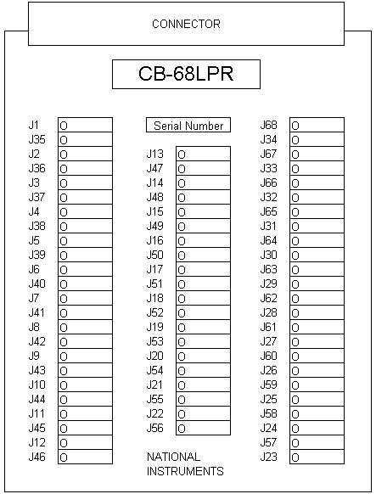

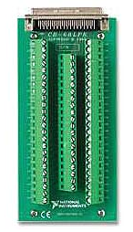

**68-Pin MIO I/O Connector Pinout**

This figure shows the pinout of 68-pin B Series and E Series devices. If you are using the R6850 or SH6850 cable assemblies with 68-pin E Series devices, refer to the[50-Pin MIO](mk:@MSITStore:C:\Program%20Files\National%20Instruments\NI-DAQ\docs\Device_Pinouts.chm::/50-Pin_MIO_IO_Connector_Pinout.html) pinout.

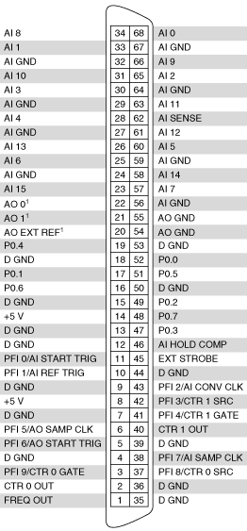

|  |  |
| --- | --- |
|  | **Note**  Further documentation for the B Series devices is located in the *E Series Help*. |

|  |  |
| --- | --- |
|  | **Note**  Some hardware accessories may not yet reflect the revised terminal names. If you are using an E Series device in Traditional NI-DAQ (Legacy), refer to the [Terminal Name Equivalents](mk:@MSITStore:C:\Program%20Files\National%20Instruments\NI-DAQ\docs\Device_Pinouts.chm::/Terminal_Name_Equivalents.html) table for information on Traditional NI-DAQ (Legacy) signal names. |

|  |
| --- |
|  |
| 1 No connects appear on pins 20 through 22 of devices that do not support AO or use an external reference.  Old Style Labeling of DAQ board pinouts PCI 6024E |



Shielded Connector Block Pinout

