Required Parts, Software and Equipment

**Parts**

20 assorted 1/4 watt resistors 5% tolerance

**Equipment**

**Required**

Solderless Experimenters' Board

Digital Multimeter

**Optional**

Alligator clip leads

hookup wire

**Software**

MS Word

**Introduction**

Many electrical circuits contain multiple variations of resistor networks. Resistors play a vital role in the distribution and limiting of electric current in a circuit. Students must learn to identify and measure the values of these components to effectively design and troubleshoot electrical and electronic circuits. Each resistor has three to five colored bands on them that represent different values. Reading and decoding these bands allows you to determine a resistor’s value and accuracy. The figure below shows the three and four band resistor color codes. Five percent tolerance resistors use the three band code on the top of the diagram.

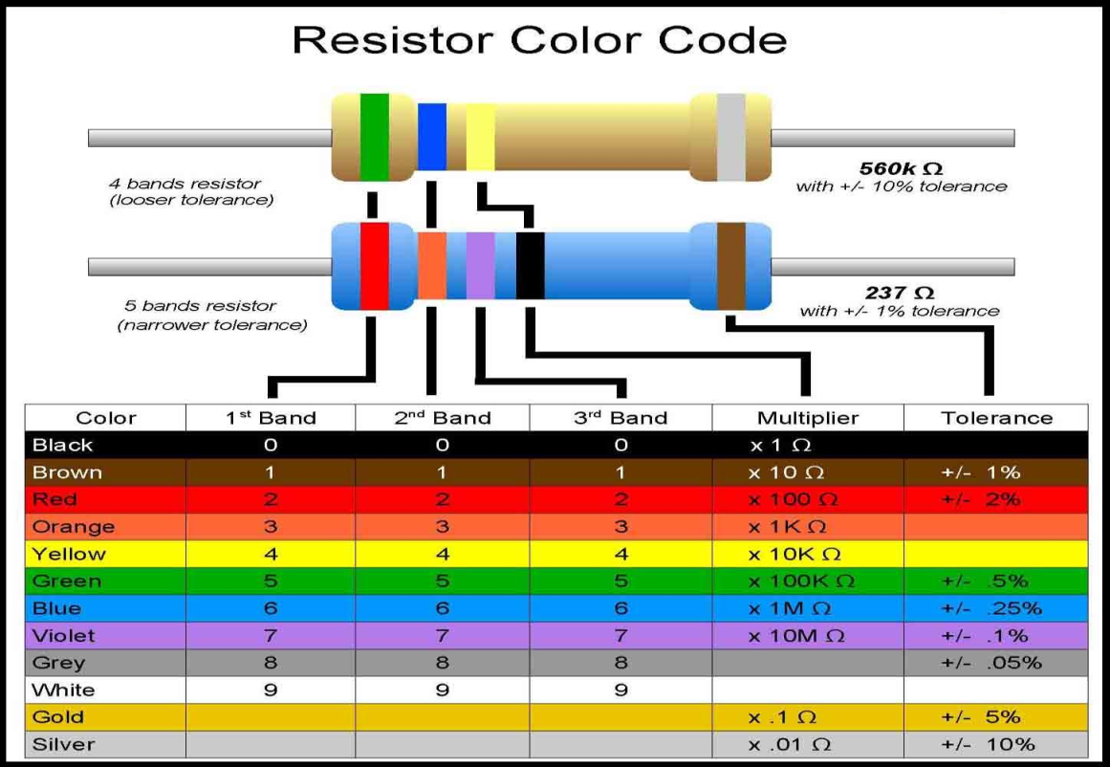

Figure 1. Three and Four Band Resistor Color Codes.

The first two or three bands determine the significant digits based on the resistor accuracy. High accuracy resistors use three bands while standard accuracy resistors use two bands. The next band is the multiplier of the significant digits. The last band is the tolerance. The tolerance is a percentage that determines the expected range of resistance values based on the marked value. The following equation shows how to compute the range of expected resistance values for a known marked value.



Where: R+ = Marked resistance plus the tolerance

R- = Marked resistance minus the tolerance

Rn = marked value or the resistor

T = tolerance in percent

Another way to identify the value of a resistor is to use a multimeter to measure its resistance. The multimeter passes a known amount of current to through its leads. The meter then measures the voltage drop across the resistor being tested and calculates the resistance using Ohm’s Law.

**Lab Objective**

The objective of this lab is to give students the opportunity to familiarize themselves with digital multimeters, resistance measurement, and the resistor color code. When the lab is completed, the student will be able to use a multimeter to measure the value of a resistor and identify its value from its color code.

**Procedure**

**1.** Place twenty given resistors on your breadboard. Make sure that there is only one resistor per row and that each leg of the resistor is in a separate row. See figure below for proper resistor placement.

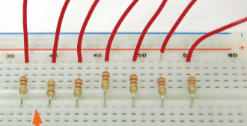

**2.** Write down the resistor band colors for each of the resistors in the table.

**3.** Using the color codes determine the components theoretical resistance.

**4.** Turn on the multimeter, set the machine to measure resistance, and hook the leads up to the machine. View the provided course videos to see how to use this instrument.

**5.** Use your multimeter to measure the actual values of the resistors. Record these values in the table.

**6.** After steps one through five have been completed return the resistors to storage. Return the multimeter and its leads to their proper spot.

**7.** Fill in the rest of the table that is provided. Use the formulas provided to compute the acceptable range for the measured resistance values.

**Discussion Points:**

These are points that should be included in your lab report. What is the significance of the colored bands on resistors? How does a multi-meter measure resistance? Why should you not hold the resistor while measuring its resistance? What happens to current when resistance is increased?

Color Abbreviations

BL = Black G = Green G = Gold

BN = Brown BU = Blue S = Silver

R = Red V = Violet

O = Orange GR = Grey

Y = Yellow W = White

Table 1

Resistor Color Codes and Measurements

|  |  |  |  |  |  |  |  |
| --- | --- | --- | --- | --- | --- | --- | --- |
| Band 1 | Band 2 | Band 3 | Band 4 | Theoretical value | R Plus  Tolerance | R Minus Tolerance | Measured Value |
|
|  |  |  |  |  |  |  |  |
|  |  |  |  |  |  |  |  |
|  |  |  |  |  |  |  |  |
|  |  |  |  |  |  |  |  |
|  |  |  |  |  |  |  |  |
|  |  |  |  |  |  |  |  |
|  |  |  |  |  |  |  |  |
|  |  |  |  |  |  |  |  |
|  |  |  |  |  |  |  |  |
|  |  |  |  |  |  |  |  |
|  |  |  |  |  |  |  |  |
|  |  |  |  |  |  |  |  |
|  |  |  |  |  |  |  |  |
|  |  |  |  |  |  |  |  |
|  |  |  |  |  |  |  |  |
|  |  |  |  |  |  |  |  |
|  |  |  |  |  |  |  |  |
|  |  |  |  |  |  |  |  |
|  |  |  |  |  |  |  |  |
|  |  |  |  |  |  |  |  |