Required Parts, Software and Equipment

**Parts**

|  |  |
| --- | --- |
| Dc and Ac Voltage Measurements | |
| Component /Value | Quantity |
| 4 AA cell battery holder | 1 |
| 2 AA cell battery holder | 2 |
| AA batteries | 8 |
| Computer/Monitor Ac line Cord | 1 |
| Step-down transformer (On-Campus only) | 1 |

**Equipment**

**Required**

Solderless Experimenters' Board

Digital Multimeter

**Optional**

Alligator clip leads

3 Banana jack leads red/black

**Software**

MS Word

**Introduction**

AC and DC power supplies are used throughout the electrical and electronics industry. Direct Current (DC) power supplies will deliver a constant voltage that does not change polarity. A battery is considered a DC source since its voltage remains constant. Alternating Current (AC) power sources have a time varying voltage. The voltage will swing from positive to negative and back to positive. This cycle continues as long as the source is turned on. The most common example of AC voltages is the wall outlet in homes and offices. This source changes polarity 60 times a second and has a nominal value of 125 V. Transformers are devices that can increase or decrease the voltage values of all AC voltages.

Voltage supplies can be arranged to either increase the current or the voltage to a given load. Batteries are commonly connected together to give higher voltages and currents than that of individual cells. When voltage supplies are connected in series, the voltage applied to the load will equal the summation of the individual sources. Figure 1 shows two AA batteries connected in series and the associate schematic diagram. If each cell supplies 1.5 volts, then the measured voltage between points A and B will be 3 volts. Figure 2 shows four AA batteries connected in series with the schematic diagram, which will produce 6 volts between the points A and B.

Battery holders have internal connections between cell with only red and black leads for external connections. The red lead connects to point A and the black lead to point B. This is the same for the four cell series string also.



Figure 1. Two Series Cells with Schematic



Figure 2. Four Cell Series Battery Connection with Schematic.

If the supplies are connected in a parallel the voltage will remain the same but the current of the supplies will be added together. Figure 3 shows two, two cell battery holders connected in parallel. The voltage measured between points C and D will be 3 volts assuming 1.5 V AA cells but the current capability will be twice that of the single string.



Figure 3. Series Parallel Connection of AA Cell Batteries. This connection Increases Current Output.

**Objective**

This lab gives students the opportunity to measure different types of voltage supplies and configurations. When the lab is completed, the students will be able to measure the voltage of both an AC and a DC power supply. Furthermore, student will be able to determine the output voltage of sources hooked up in series and parallel. Students gain experience with the multimeter in the voltage measurement mode.

**Procedure**

**DC Source Measurements**

1. Obtain eight AA batteries, one four-cell battery pack, and two, two-cell battery packs. Measure the voltage of each battery using your multimeter. Place these values in the table.
2. Put batteries in all of the battery holders. Note the polarity of the batteries as you place them into the battery holders.
3. Measure the voltage of each battery pack. Place these values in the table.
4. Connect the two 2 cell battery packs in series and measure the total voltage. Place this value in the table.
5. Connect the two 2 cell battery packs in parallel and measure the total voltage. Place this value in the table.
6. Remove all the batteries from the holders and store all batteries and holders.

**AC Source Measurements On-Campus Students Only**

1. Obtain the AC transformer box and a line cord from the course instructor. This device is shown in Figure 4. Connect the line cord to the transformer box and turn it on. An in indicator light should light up. Set the multimeter to measure AC voltage.

2. Place the red probe in the first hole and the black probe in the middle hole. Record this voltage measurement in Table 2 at the end of this document.

3. Move the black probe from the middle hole to the third hole. Record this measurement in Table 2.

4. Move the red probe from the first hole and place it in the middle hole. Record this measurement in Table 2 also.

5. Return all equipment to it proper storage area and power down the multimeter.

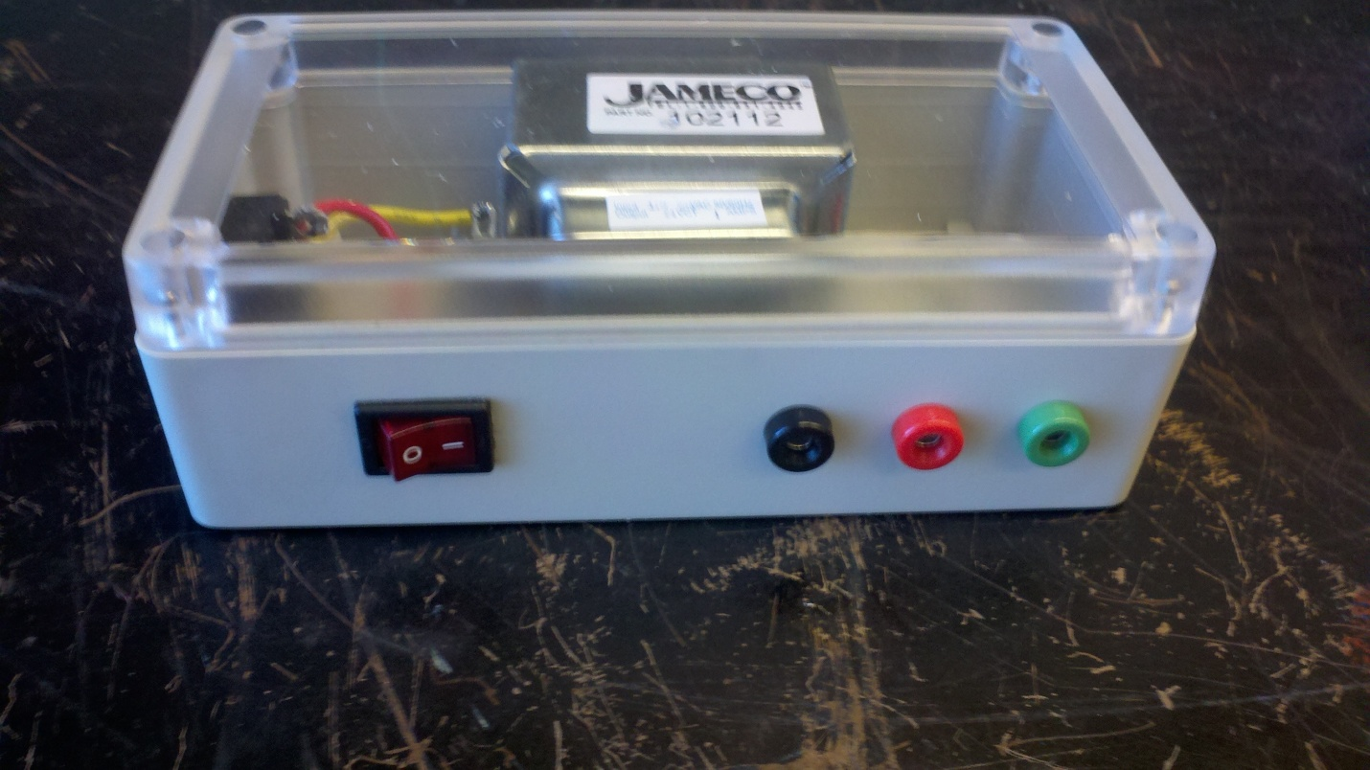

First

Middle

Third

Figure 4. Ac Transformer Test Box. Only Available for On-Campus Students.

**AC Source Measurements On-line Students Only**

**CAUTION: THIS ACTIVITY REQUIRES THE MEAUREMENT OF LINE VOLTAGE DIRECTLY FROM A POWER OUTLET. HAZARDOUS VOLTAGES ARE PRESENT IN THIS ACTIVITY. USE EXTREME CAUTION WHEN MAKING THE REQUIRED CONNECTIONS . THE METALIC PARTS OF THE TEST PROBES MUST NOT BE EXPOSED OR TOUCHED WHILE COMPLETING THE REQUIRED MEASUREMENTS.**

AC wall outlets must be wired according to the National Electrical Code, which specifies the location of the voltage lead, the neutral lead and the safety ground lead. The neutral and the safety ground leads should be at the same electrical potential in a correctly wired system. These two points will register zero volts on the multimeter set to read AC voltage. The voltage reading between the safety ground and the voltage lead should read an ac value between 108 – 132 V. This activity shows how to check the connections of the line voltage using a multimeter.

1. Obtain the AC line cord from the recommend dc power supply for the program. Another source for this cord is any desk-top computer or screen. Figure 5 shows the end of the cord that connects to the powered equipment. Connect the plug end of the cord into a wall outlet. Review the video provided in the course materials before proceeding with this activity. Contact the course instructor if you have any questions or concerns before proceeding to the next steps.



Figure 5. Power Cord End View Showing the Location of the Safety Ground.

1. Obtain the multimeter. Turn it on and set it to the highest AC range.
2. Connect the black multimeter lead to the safety ground location by inserting the probe tip into the hole in the cord. Carefully insert the red multimeter lead into position A shown in Figure 6. Do not contact any bare metal parts of the probe tip with your skin when making this connection. Note the voltage reading and place it in the first entry of Table 3 at the end of the lab.



Figure 6. Test Point Locations.

1. Keep the black multimeter lead in the safety ground position. Remove the red lead from point A and insert it into point B. Use caution when inserting the probe tip into this point so that no contact is made between bare metal and skin. Note the voltage reading and place it in Table 3.
2. Repeat step 4, only place the red lead into the safety ground. Make the measurement and place it into Table 3.
3. Repeat step 4, only keep the red lead in the safety ground position. Make the measurement and place it into Table 3.
4. Remove the multimeter leads from the line cord and power the meter off. Disconnect the line cord from the wall outlet and store all equipment.

**Discussion Points**

**All Students**

What is the difference between AC and DC voltage sources? What happens when you connect DC voltage sources in series? What happens when you connect DC sources in parallel?

**On-Campus Students**

What did you notice about the different AC measurements? What is the relationship between the voltages at the transformer test points?

**On-line Students**

Did reversing the multimeter leads have any effect on the measurements? Is the outlet wired correctly? Is the line voltage within the specified range?

Table 1-Dc Voltage Measurements

|  |  |  |  |  |  |
| --- | --- | --- | --- | --- | --- |
|  | AA Batteries | 4 Cell Pack | 2 Cell Pack | 2 Cell Series | 2 Cell Parallel |
|  |
| 1 | V | V | V | V | V |
| 2 | V |  |  |  |  |
| 3 | V |  |  |  |  |
| 4 | V |  |  |  |  |
| 5 | V |  |  |  |  |
| 6 | V |  |  |  |  |
| 7 | V |  |  |  |  |
| 8 | V |  |  |  |  |

Table 2-Ac Measurements On-Campus Students Only

|  |  |
| --- | --- |
| Lead Location | Measured Ac Voltage (V) |
| First- Middle |  |
| First-Third |  |
| Middle-Third |  |

Table 3- Ac Measurement On-line Students Only

|  |  |
| --- | --- |
| Lead Location | Measurement Ac Voltage |
| Black lead – Safety Ground  Red lead- Point A |  |
| Black lead – Safety Ground  Red lead- Point B |  |
| Red lead-Safety Ground  Black lead-Point A |  |
| Red lead-Safety Ground  Black lead-Point B |  |