ECE424 (Fall-12) Lab4: Security Functions
Instructor: Dr. NingWeng, nweng@siu.edu
TA: Cheng-Liang Hsieh, isapapa@siu.edu
Due: 2012/12/7, 11:59 p.m., Submit your code and report by Desire2Learn
The goal of this lab is to learn how to implement security functions on the applications with network capability by Qt software development framework. Qt has a module called QtNetwork to support network capability. Under this module, QTcpServer class provides a TCP-based server to accept incoming TCP connections and QTcpSocket provides a TCP socket for a reliable, stream-oriented, connection-oriented communication between two nodes. QSslSocket which inherits QTcpSocket establishes a secure, encrypted TCP connection for transmitting encrypted data.
In this lab, we will simulate a situation that a client application needs to check with the server application to see if the current user is valid or not just like what we did in Lab3. However, the communication between client and server will be encrypted this time. In this lab, we will use OpenSSL to generate a self-signed certificated and a private key first. Then we will use these two keys to implement a Socket Layer Security (SSL) or Transport Layer Security (TLS) communication between client and server.
Please refer to following links for more materials which are related to this lab.
- Qt Network Module
http://doc.qt.digia.com/qt/qtnetwork.html
- OpenSSL
http://www.openssl.org/
OpenSSL W32 Installer
http://slproweb.com/products/Win32OpenSSL.html
OpenSSL Command Line HowTo
http://www.madboa.com/geek/openssl/#intro-version
- Guide to SSL certificates and certificate authorities
http://doc.qt.digia.com/solutions/qtsslfilter/sslguide.html
- How SSL Works
http://www.youtube.com/watch?v=iQsKdtjwtYI
http://www.youtube.com/watch?v=JjMfuJOnHzc&feature=fvwrel
- About security for TCP/IP clients
http://publib.boulder.ibm.com/infocenter/cicsts/v3r1/index.jsp?topic=%2Fcom.ibm.cics.ts31.doc%2Fdfht5%2Ftopics%2Fdfht5kt.htm
Step 1: Generate Private Key and Self-signed Certificate
- Install OpenSSL Tool Kit
For Linux user, please visit following link and get the source. You have to compile the source by yourself.
http://www.openssl.org/source/
For Windows user, please visit following link to get the installer.
http://slproweb.com/products/Win32OpenSSL.html

- Enter the command line interface of your platform and visit where OpenSSL is installed. Use following command to generate private key and a self-signed certificate for server.
openssl.exe req -newkey rsa:1024 -keyout server.key -nodes -days 365 -out server.crt
Then enter all necessary data for your key and certificate. Following is a capture for your reference.
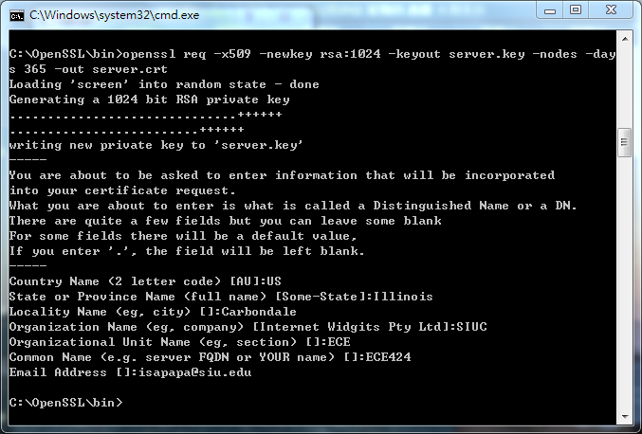
Figure 1: Private Key and Self-signed certificate
- Use following command to generate private key and a self-signed certificate for client.
openssl.exe req -newkey rsa:1024 -keyout client.key -nodes -days 365 -out client.crt
- Copy server.key, server,crt, client.key, and client.crt to a folder you assign for this lab.
- Use any editor tool to open server.key that you just create. You should be able to find a format like following.
-----BEGIN PRIVATE KEY-----
MIICdgIBADANBgkqhkiGggJcAgE0Qcy4THQ
9w0BAQEFAASCAmAw…
AAoGBAL8O0ho72LvzbWgC3Nwjsw==
-----END PRIVATE KEY-----
- Use any editor tool to open server.crt that you just create. You should be able to find a format like following.
-----BEGIN CERTIFICATE-----
MIIC1jCCAj+gAqGMIGDMQswCQYD
wIBAgIJAK/7/e6Hjy0RMA0GC
SIb3DQEBBQUA+a1MuhMrA2vJMw==
-----END CERTIFICATE-----
Q1: What is a private key?
Q2: What is a Certificate?
Q3: Why we use self-signed certificate for this lab?

Step 2: Design a TCP Server application with security function
- For this lab, we would like implement a security function by using SSL/TLS. Qt provides a QSslSocket class can help us to achieve this goal. A SSL/TLS Socket works like a normal TCP socket but is equipped with some additional functions for SSL/TLs standard.
- In lab3, we design a class to handle TCP socket. This time we design a class to handle SSL socket. By setting the base class as QSslSocket as following:
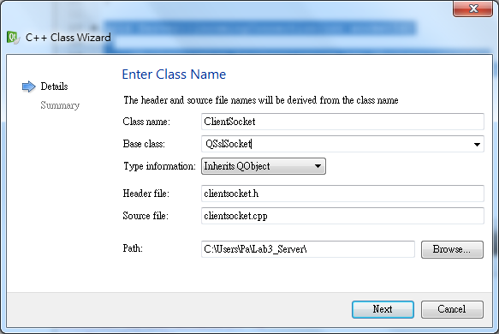
Figure 2: Add a new class for server to handle SSL socket.
- To handle any SSL connection, we overwrite the incomingConnection() of TCP sever as following:
void Server::incomingConnection(int socketId)
{

ClientSocket *socket = new ClientSocket(this);
socket->setSocketDescriptor(socketId);
socket->setPrivateKey("D:/server.key");
socket->setLocalCertificate("D:/server.crt");
socket->setPeerVerifyMode(QSslSocket::QueryPeer);
socket->setProtocol(QSsl::TlsV1);
socket->startServerEncryption();

}
Q4: What is the SSL/TLS handshake process?
Q5: What information is necessary for authentication in SSL/TLS?
Q6: What is the purpose to call setSocketDescriptor() in the above code?
Q7: What is the purpose to call startServerEncryption() in the above code?
- For the new class we just create to handle any SSL connection, we define the class constructor as following:
ClientSocket::ClientSocket(QObject *parent)
: QSslSocket(parent)
{
createDatabaseConnection();
connect(this, SIGNAL(encrypted()), this, SLOT(showEncrypted()));
connect(this, SIGNAL(readyRead()), this, SLOT(readClient()));
connect(this, SIGNAL(disconnected()), this, SLOT(deleteLater()));
nextBlockSize = 0;
}
void ClientSocket::showEncrypted()
{
qDebug()<<"showEncrypted() is enabled.";
}
Q8: What is the purpose to call encrypted() in the above code?
Q9: What is the purpose to call deleteLater() in the above code?
Q10: (4 points) Define all necessary functions of Server application to make sure the server will be able to save/retrieve account data and to save/retrieve patient’s measurement data into/from a database.

Step 3: Design a TCP client application with security function
- Just like what we did in Lab3, we are now working on SSL Socket instead of TCP socket. Hence, we need to define a SSL Socket for the client application.
QSslSocket sslSocket;

- Please note that all SSL settings have to been done before you initial a SSL connection. All settings of client application must match the settings of server end for a successful connection.

- Once all settings are ready, you can call “connectToHostEncrypted()” to connect to the Server.

Q11 (2 points): Please design the client application to make sure it can set up an encrypted channel with server correctly.
Q12 (1 points): Please design the client application to make sure it can update the central widget once it the response from server.
Q13 (4 points): Please design the client application to make sure all functions can work and interact with server application correctly.
Q14 (Bonus problem: 5 points): Find a 3rd party packet (QCA, Crypt++) which support both public-key and symmetric-key encryption. Integrate this 3rd party packet into the Qt. Then design your program to encrypt a 100MB file then de-encrypt it. Show the performance difference between public-key and symmetric-key encryption.

